Screenshots or program listings must be copied into appropriate cells in the following table.
Save this evidence document as evidence_ followed by your centre number_ candidate number. For example: evidence_ zz999_9999 and insert your name, centre number and candidate number into the header above.
Examiners must be able to read the contents including any screenshots without the use of a magnifying glass. Answers that are not readable or missing will not be awarded any marks.
Save this evidence document at regular intervals, for example, every 10 minutes.
Question 1
Part 1(a)
{Copy and paste the program code for question 1(a) here}

def Unknown(x,y):
if x<y:
print(x+y)
return(Unknown(x+1,y)*2)
else:
if x==y:
return 1
else:
print(x+y)
return(Unknown(x-1,y)//2)

Part 1(b)(i)
a=10
b=15
print(f"x={a}, y={b}")
print(Unknown(a,b))
b=10
print(f"x={a}, y={b}")
print(Unknown(a,b))
a=15
print(f"x={a}, y={b}")
print(Unknown(a,b))

Part 1(b)(ii)
{Copy and paste the screenshot for question 1(b)(ii) here}

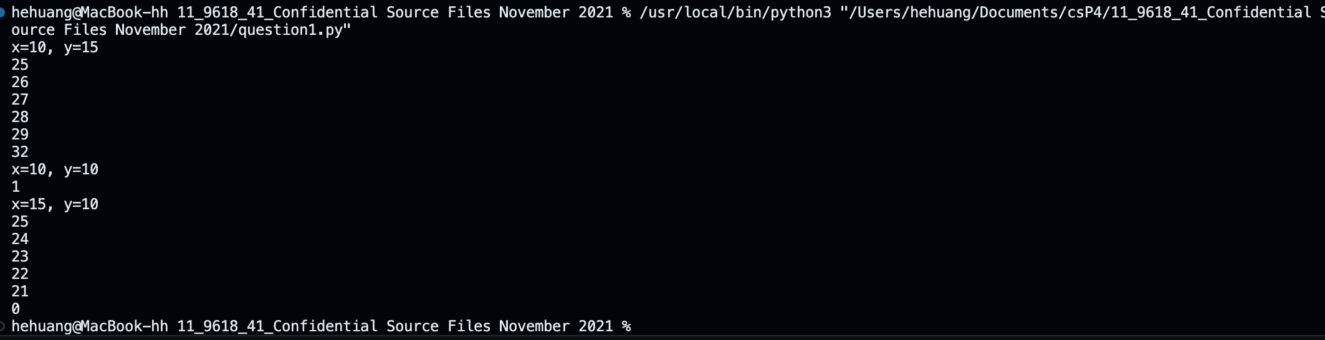

Part 1(c)
{Copy and paste the program code for question 1(c) here}

def IterativeUnknown(m,n):
result=1
while m!=n:
print(m+n)
if m>n:
m-=1
result//=2
else:
m+=1
result*=2
return result

Part 1(d)(i)
{Copy and paste the program code for question 1(d)(i) here}

a=10
b=15
print(f"x={a}, y={b}")
print(f"m={a}, n={b}")
print(Unknown(a,b))
print(f"IterativeUnknown reselt is: {IterativeUnknown(a,b)}")
b=10
print(f"x={a}, y={b}")
print(f"m={a}, n={b}")
print(Unknown(a,b))
print(f"IterativeUnknown reselt is: {IterativeUnknown(a,b)}")
a=15
print(f"x={a}, y={b}")
print(f"m={a}, n={b}")
print(Unknown(a,b))
print(f"IterativeUnknown reselt is: {IterativeUnknown(a,b)}")

Part 1(d)(ii)
{Copy and paste the screenshot(s) for question 1(d)(ii) here}

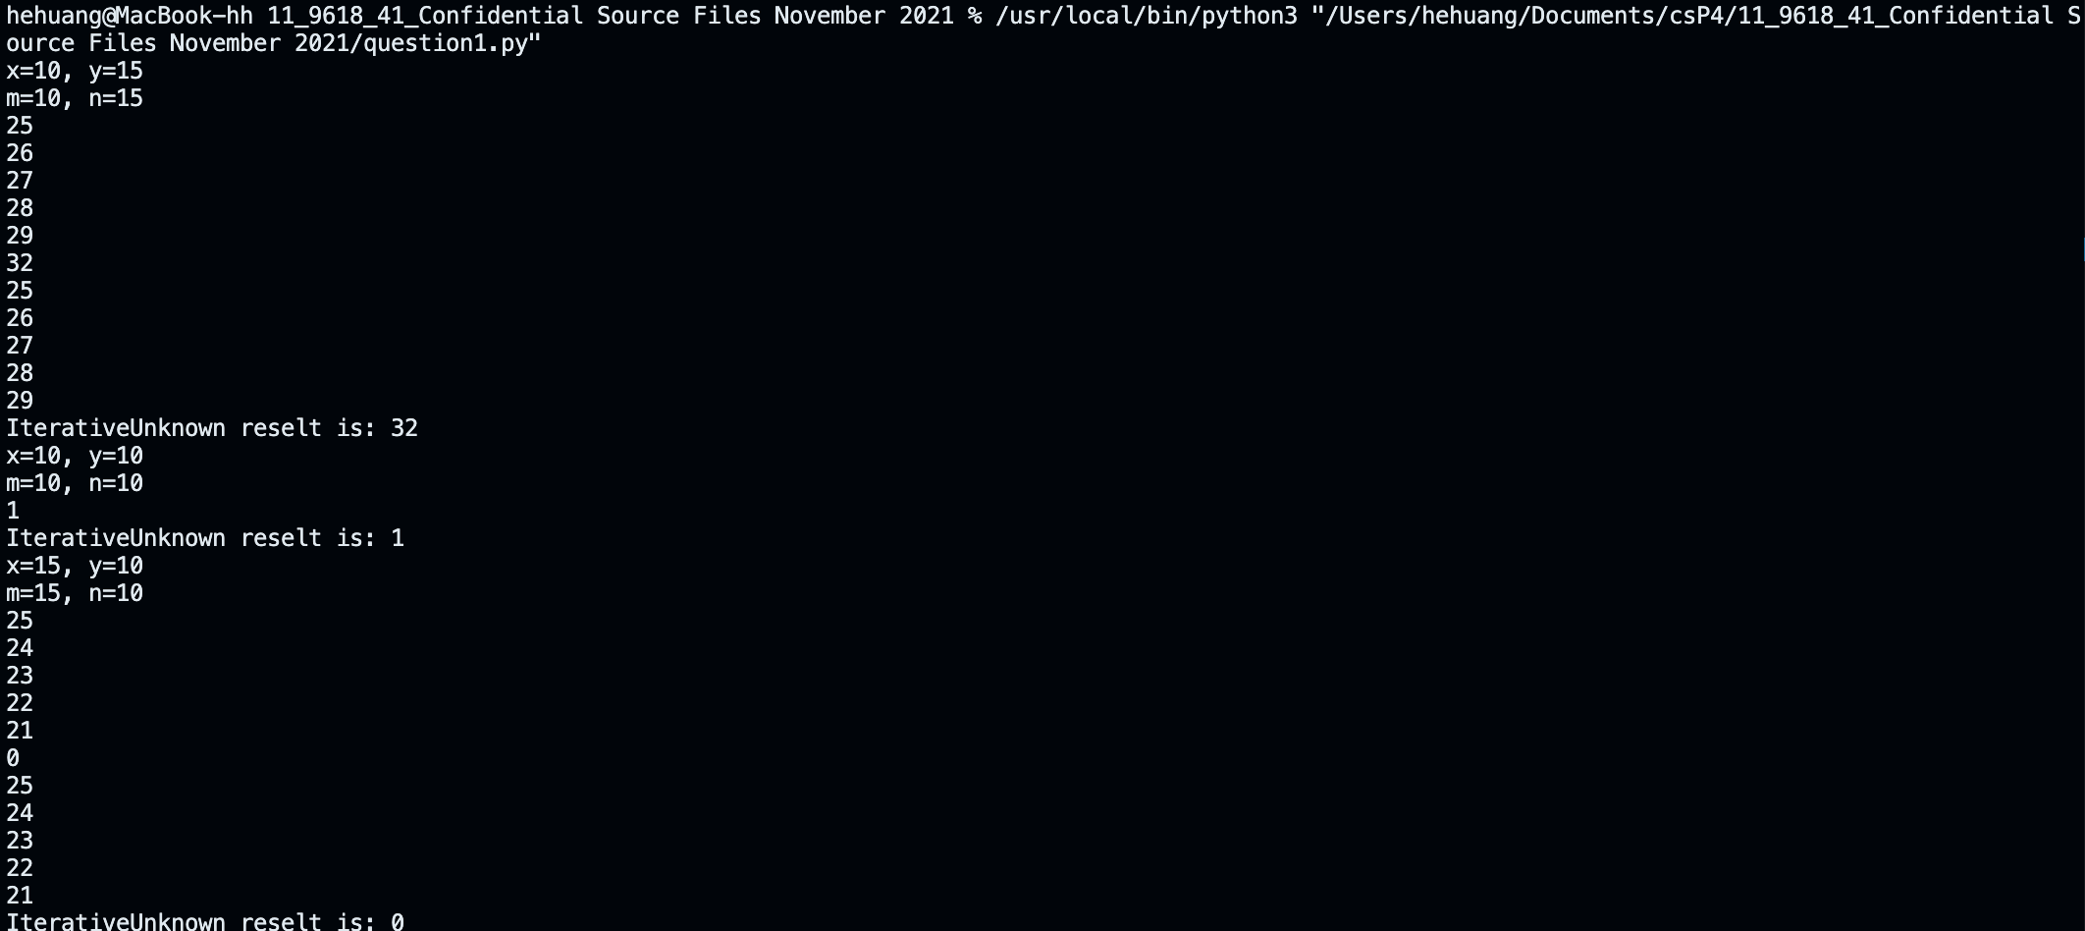

Question 2
Part 2(a)
{Copy and paste the program code for question 2(a) here}

class Picture:
def __init__(self,description,w,h,framecolour):
# private Description: String
# private Width: Integer
# private Height: Integer
# private FrameColour: String
self.__Description=description
self.__Width=w
self.__Height=h
self.__FrameColour=framecolour

Part 2(b)
{Copy and paste the program code for question 2(b) here}

def getDescription(self):
return self.__Description
def getWidth(self):
return self.__Width
def getHeight(self):
return self.__Height
def getFrameColour(self):
return self.__FrameColour

Part 2(c)
{Copy and paste the program code for question 2(c) here}

def SetDescription(self,newdescrption):
self.__Description=newdescrption

Part 2(d)
{Copy and paste the program code for question 2(d) here}

# PicArray: ARRAY[0:99] OF Picture
PicArray=[None for _ in range(100)]

Part 2(e)
{Copy and paste the program code for question 2(e) here}

def ReadData():
global PicArray
try:
count=0
f=open("Pictures.txt")
x=f.read().split()
while count < len(x):
y=x[count:count+4]
count+=4
PicArray[count//4]=Picture(y[0],int(y[1]),int(y[2]),y[3])

f.close()
return count//4
except FileNotFoundError:
print("File Not Found.")

Part 2(f)
{Copy and paste the program code for question 2(f) here}

# PicArray: ARRAY[0:99] OF Picture
PicArray=[None for _ in range(100)]
ReadData()

Part 2(g)
{Copy and paste the program code for question 2(g) here}
# PicArray: ARRAY[0:99] OF Picture
PicArray=[None for _ in range(100)]
ReadData()

x=input("Enter your requirements for a picture(colour of the frame) ").lower()
y=int(input("Enter your requirements for a picture(max width) "))
z=int(input("Enter your requirements for a picture(max height)) "))
for pic in PicArray:
if pic is None:
continue
if x==pic.getFrameColour() and y>=pic.getWidth() and z>=pic.getHeight():
print(f"{pic.getDescription()}, width:{pic.getWidth()}, height:{pic.getHeight()}")

Part 2(h)
{Copy and paste the screenshot(s) for question 2(h) here}

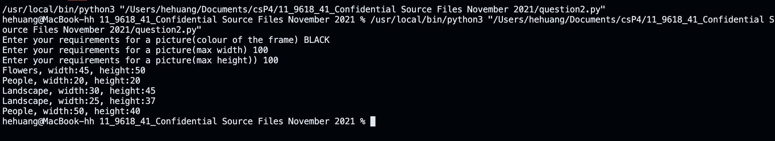

Question 3
Part 3(a)
{Copy and paste the program code for question 3(a) here}

# ArrayNodes: ARRAY[0:2,0:19] OF INTEGER
# RootPointer: Integer
# FreeNode: Integer
ArrayNodes=[[None for _ in range(3)]for _ in range(20)]
RootPointer=-1
FreeNode=0

Part 3(b)
{Copy and paste the program code for question 3(b) here}

def AddNode():
global ArrayNodes, RootPointer, FreeNode
NodeData=int(input("Enter the data"))
if FreeNode<=19:
ArrayNodes[FreeNode,0]=-1
ArrayNodes[FreeNode,1]=NodeData
ArrayNodes[FreeNode,2]=-1
if RootPointer == -1:
RootPointer=0
else:
Placed=False
CurrentNode=RootPointer
while not Placed:
if NodeData<ArrayNodes[CurrentNode,1]:
if ArrayNodes[CurrentNode,0]==-1:
ArrayNodes[CurrentNode,0]=FreeNode
Placed=True
else:

CurrentNode=ArrayNodes[CurrentNode,0]
else:
if ArrayNodes[CurrentNode,2]==-1:
ArrayNodes[CurrentNode,2]=FreeNode
Placed=True
else:
CurrentNode=ArrayNodes[CurrentNode,2]
FreeNode+=1
else:
print("Tree is full")

Part 3(c)
{Copy and paste the program code for question 3(c) here}

def PrintAll():
global ArrayNodes
for item in ArrayNodes:
if item[1] is not None:
print(f"{item[0]} {item[1]} {item[2]}")

Part 3(d)(i)
{Copy and paste the program code for question 3(d)(i) here}

# ArrayNodes: ARRAY[0:2][0:19] OF INTEGER
# RootPointer: Integer
# FreeNode: Integer
ArrayNodes=[[-1,None,-1]for _ in range(20)]
RootPointer=-1
FreeNode=0
for j in range(10):
AddNode()

PrintAll()

Part 3(d)(ii)
{Copy and paste the screenshot for question 3(d)(ii) here}

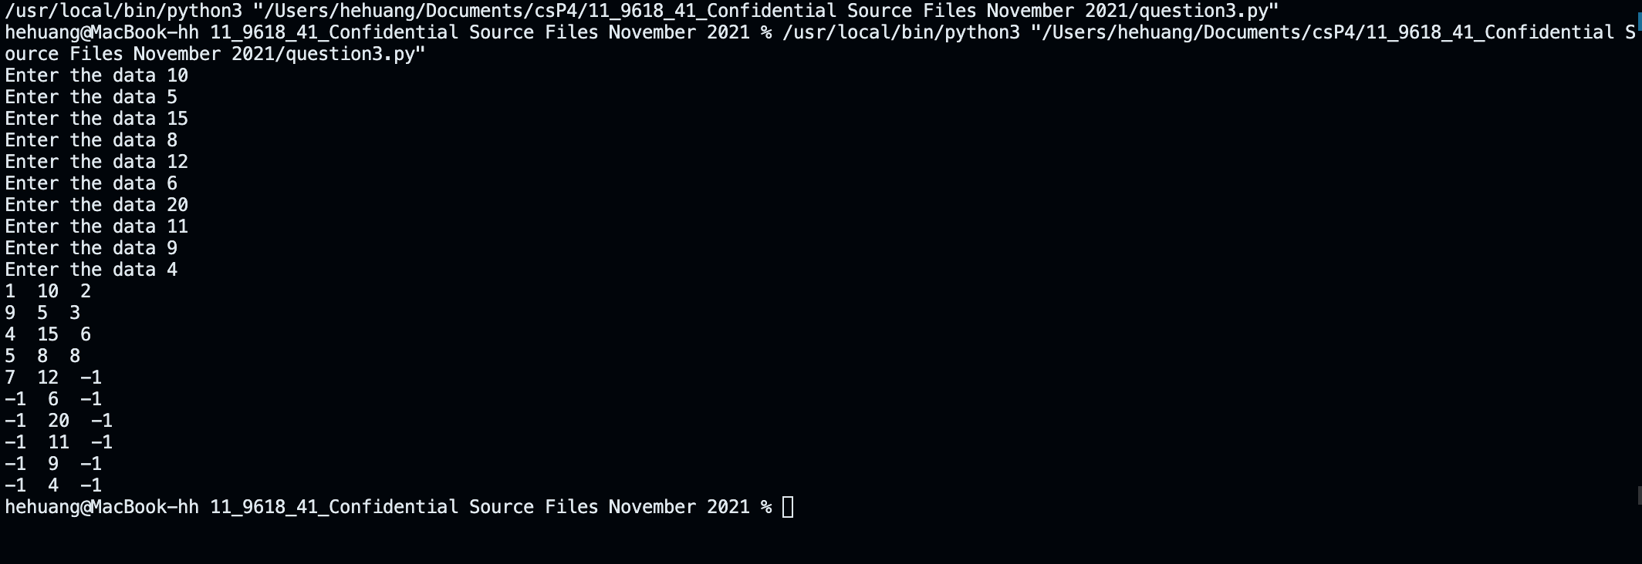

Part 3(e)(i)
{Copy and paste the program code for question 3(e)(i) here}

def InOrder(ptr):
global ArrayNodes

if ArrayNodes[ptr][1] is not None:
InOrder(ArrayNodes[ptr][0])
print(ArrayNodes[ptr][1])
InOrder(ArrayNodes[ptr][2])

Part 3(e)(ii)
{Copy and paste the screenshot for question 3(e)(ii) here}

